1531 Group - Report

Group member 1:Peiwen Xu – z5098118

Group member 2:Haoyang Wu – z5177881

Group member 3: The Minh Tran – z5075710

Priority Scaling: 1-5. 1 being of lowest priority. 5 being of highest priority.

User-story points (USP): 1 USP = 6 hours.

Epic User Story

C-EP1: As an online customer, I want to place an online order from two types of mains, add sides or drinks to my order if I wish, checkout my order and check the status of my order, so I can be efficient with my time.

S-EP1: As a staff that services orders and maintains inventory, I want to be able to view current orders, change the status of the order and view the overall inventory of the store so I can perform my duties as staff efficiently.

|  |  |
| --- | --- |
| ID | C-US1 |
| Name | Ordering from two types of mains |
| User-Story Description | As an online customer, I want to be able to order from two types of mains, so I can enjoy my preferred choice. |
| Priority | 4 |
| USP | 1 |
| Acceptance  Criteria | * The two types of mains the customer can choose from are: burger or wrap. * The base price of the mains are displayed in AUD for the customer to see. |

|  |  |
| --- | --- |
| ID | C-US2 |
| Name | Gourmet Creation (modification process) |
| User-Story Description | As an online customer, I want to be able to modify the buns, patties and other ingredients of my selected type of main, so only ingredients I enjoy are included in the meal. |
| Priority | 3 |
| USP | 2 |
| Acceptance  Criteria | * The customer can modify the type of buns for their selected type of main. Some examples of bun types are: muffin buns and sesame buns. * Next, the customer can modify the number of buns but there is a limit on the number of buns the customer can modify based on the type of burger permitted. For example, if the permitted burgers are single, double and triple burgers, then the limit of modification on the customer is 4. * Afterwards, the customer can modify the type of patties for their selected type of main. Some examples of patty types are: chicken, vegetarian and beef patties. * Finally, the customer can modify the number of patties for their selected type but there is a maximum limit on the number of patties based on the permitted burgers. * All selections for the modifications are chosen from a list ranging from the allowable minimum to the allowable maximum to prevent customers from entering invalid inputs. * Default selection should be on the allowable minimum from the list. * The customer may select a different value from a modification list if they change their mind. * The customer can add other ingredients to their selected type of main. Some examples (but not limited to) of other ingredients are: tomato, lettuce, tomato sauce and Swiss cheese. * Each ingredient displays the price in AUD for its inclusion for the customer. |

|  |  |
| --- | --- |
| ID | C-US3 |
| Name | Add sides or drinks to order |
| User-Story Description | As an online customer, I should have the choice to add sides or drinks to my order, so I do not have to make separate orders for the sides or drinks. |
| Priority | 2 |
| USP | 2 |
| Acceptance  Criteria | * The customer has several size and quantity options available on display such as: 3 pack nuggets or 6 pack nuggets or,   75g (small), 125g (medium) or 175g (large) fries or,  375mL (can) or 600mL (bottled) drink, or  250mL (small) or 450mL (medium) orange juice.   * The price to add each side is displayed in AUD for the customer. * There is a one-line text box next to each side where a customer can enter the number of sides they would like to order. * A negative number submitted should return the customer to the same page and display a message stating only positive integers should be entered. |

|  |  |
| --- | --- |
| ID | C-US4 |
| Name | Checkout the order |
| User-Story Description | As an online customer, I want to be able to complete and checkout my order so I do not have to inconveniently pay at an outlet. |
| Priority | 5 |
| USP | 3 |
| Acceptance  Criteria | * The entire ordering process is completed online and sent to the outlet staff. * The total net price is displayed for the customer in AUD. * The customer may make changes to their choices by clicking on a “go back” button that returns them to the beginning. * The customer must checkout to complete their order. * If no payment is made during checkout, the order will not be complete. * If no payment is made within a time limit, the order is automatically cancelled. * An order-ID is issued to the customer and may collect their order using this ID. * If there is insufficient inventory to service a customer’s order, the order will not go through and the customer is returned to the customisation page. A message should be displayed to let the customer know what has happened. |

|  |  |
| --- | --- |
| ID | C-US5 |
| Name | Check status of order |
| User-Story Description | As an online customer, I want to be able to check the status of my order so I know when my order is ready. |
| Priority | 1 |
| USP | 2 |
| Acceptance  Criteria | * If the order is not ready, the status page displays for the customer “Not ready”. * If the order is ready, the status page displays for the customer “Ready”. * If an order changes while the customer is still on the status page, the customer will need to refresh to see the updated change. * The status page also displays the details of what the customer ordered. * If the customer has left the page, they can enter their order ID to view the current status of their order. |

|  |  |
| --- | --- |
| User-Story Description | As an online customer, I want to be able to order a base burger or base wrap so I save time. |
| Priority | 2 |
| USP | 2 |
| Acceptance  Criteria | * There should be a choice to choose either a base wrap, base burger or to proceed to the customisation step. * Selecting a ‘base’ option will skip the customisation process and proceed to payment and order placement. * If there is insufficient inventory, the order will not go through and the customer will be sent back to pick a new option. A message should also be displayed to let the customer know what has happened. * If there is sufficient inventory, the order will go through and the inventory levels will decrease. * The price for each ‘base’ item is displayed in AUD for the customer. |

|  |  |
| --- | --- |
| ID | S-US1 |
| Name | View current orders |
| User-Story Description | As a staff who is servicing orders, I want to be able to view the current orders on demand so I can avoid misplacing orders |
| Priority | 5 |
| USP | 2 |
| Acceptance  Criteria | * Orders that have the status of “Not ready” are available for view. * Orders are, when placed by customers, set to “Not ready” by default. * The order displays the order ID and the contents of the customer’s order. * Orders that have the status set to “Ready” are removed from view. |

|  |  |
| --- | --- |
| ID | S-US2 |
| Name | Update status page |
| User-Story Description | As a staff who is servicing orders, I want to be able to update the status page for customers so I can quickly move on to the next order. |
| Priority | 4 |
| USP | 3 |
| Acceptance  Criteria | * From the viewing page, a staff can press on a button for each order they would like to set the status to “Ready”. * If an order is set to “Ready” it is removed from the order viewing list. * Customers can refresh their status page to see the change in status. |

|  |  |
| --- | --- |
| ID | S-US3 |
| Name | View overall inventory |
| User-Story Description | As a staff that maintains inventory, I want to be able to view the overall inventory of my outlet so that I know when to restock inventory. |
| Priority | 4 |
| USP | 3 |
| Acceptance  Criteria | * All burgers, wraps and nuggets are displayed in whole quantities. * All canned drinks are stocked in 375mL cans and displayed in whole quantities (For example, 100x 375mL cans of Coke). * All bottled drinks are stocked in 600mL bottles and displayed in whole quantities (For example, 100x 600mL bottles of Coke. * Other drinks (such as orange juice) are stocked by volume: 250mL (small) and 450mL (medium). * Other sides and ingredients (such as fries and patties) are stocked by weight: 75g (small) and 125g (medium). * Sundaes are stocked by volume: 200mL (small) chocolate or strawberry sundae, 400mL (medium) chocolate or strawberry sundae and 600mL (large) chocolate or strawberry sundae. * Stock values must be non-negative integers. * If a customer orders an item, the respective stock value is deducted based on that item. * Inventory is checked on each checkout. * If inventory is insufficient, the order does not go through and inventory levels do not change. |

|  |  |
| --- | --- |
| ID | S-US3 |
| Name | Restock inventory |
| User-Story Description | As a staff that maintains inventory, I want to be able to update inventory levels so the store can operate. |
| Priority | 4 |
| USP | 4 |
| Acceptance  Criteria | * A one line text box is placed next to each inventory stock where a staff can enter the numbers to restock inventory levels. * Inventory levels should increase upon pressing submit for each item entered for. * Multiple inventory stocks can be updated at once. * There are instructions are the top of the inventory management page that warns the user not to enter negative numbers. Additionally, the instructions state that only positive integers should be used and that each input should be double checked. * Empty inputs are valid but should not alter inventory levels. |

Final UML diagram:

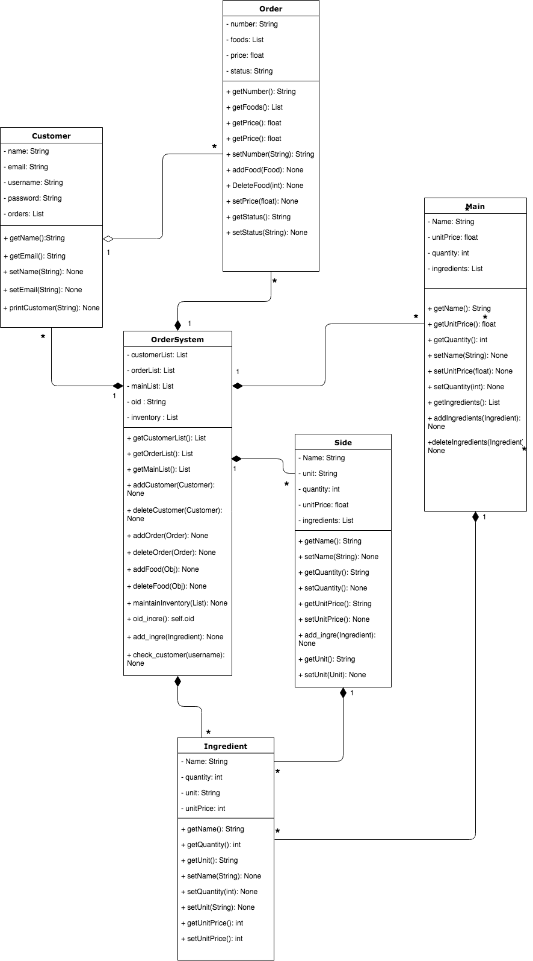

Entity-Relationship (ER) Design:

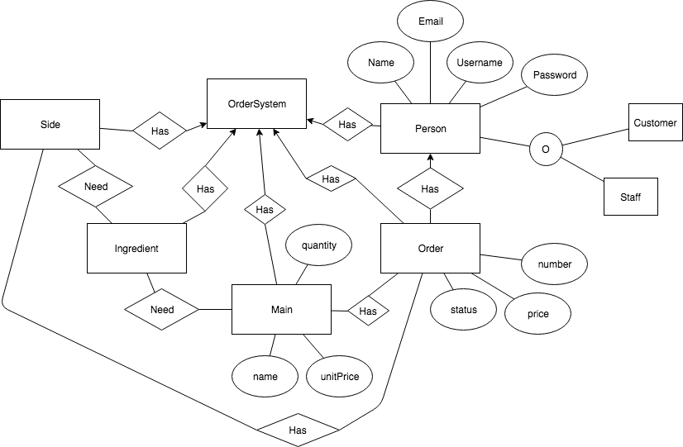

# Logbook

Date | Task

5/3/19 Regular lab meeting: our group decided to assigned "Milestone 1". Every group. Member should finish one part of the User-Story this week. Minh will write epic stories and user stories for "Customer - Online Orders". Haoyang will write epic stories and user stories for "Staff - Service Orders". Peiwen will write epic and user stories for "Staff - Maintain Inventory". Then combine the each epic stories into one main.

26/3/19 Regular lab meeting: group members shared their ideas about class diagram. for "Milestone 2". Some significant classes with clear objects and methods were defined, including order system, customer and so on. The next thing our group did was to determine and show the relationship between classes. As shown below, CRC cards was done. Focusing on the implementation of the restaurant order system and making detailed plan of how to accomplish each part would be the task of this week. Haoyang would record the meeting to write the logbook.

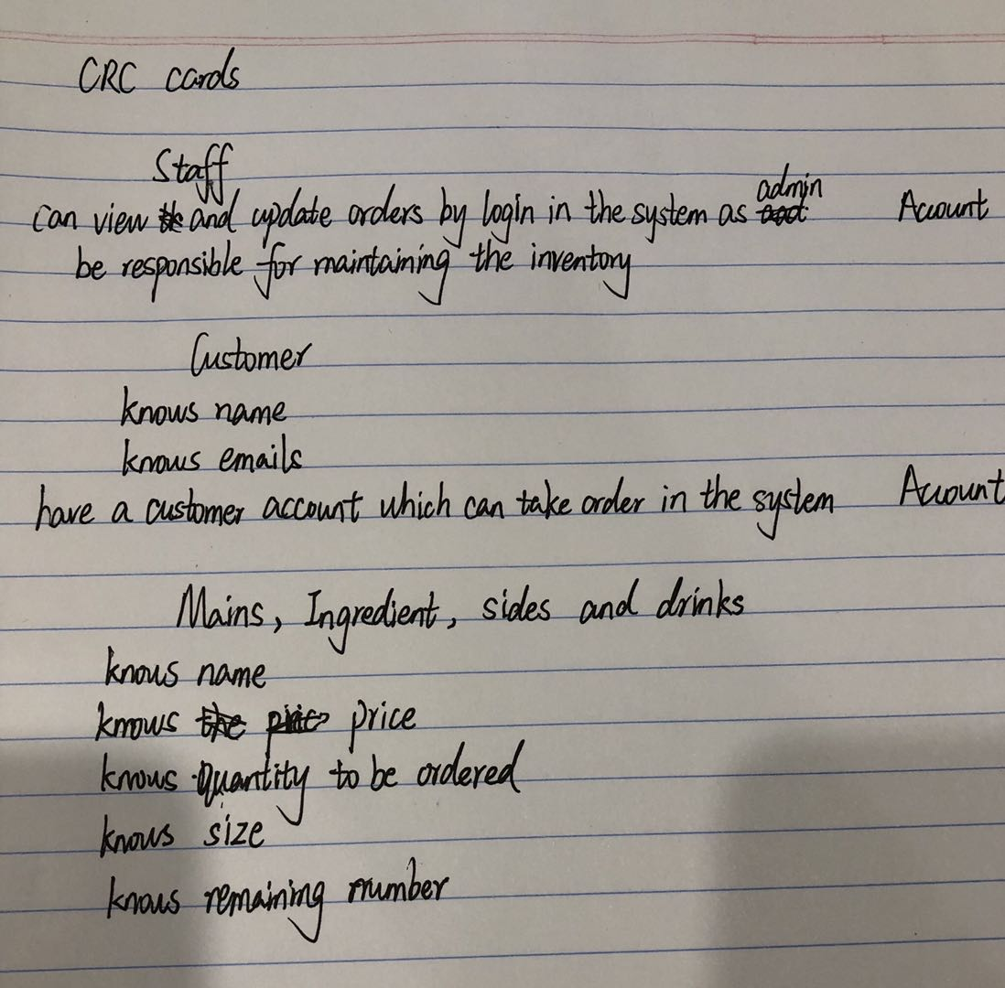

2/4/19 Regular lab meeting: the feedback of class diagram was given by tutor this week. We missed the relationship between order and food which should be aggregation. Customers should be also added the burger list so that they can choose different ingredient that satisfies their favor. The most important task is that the software system needs to be built and the test cases should be accomplished. We are required to make sure that customers are able to place their order and staff can process the order. The implementation of different classes which includes customer, staff, order, order system, food, ingredient, sides and drinks assigned to each member separately. Minh would take the responsibility of the food part, including main, ingredient, sides and drinks. Peiwen would do the customer, staff, order and order system together with Haoyang.

8/4/19 Regular lab meeting: The working of the back-end software needed to be presented in this week’s lab. As for feedback, we were told that the error messages which use exception statement could be used to improve the performance of the system. Furthermore, the tasks needed to be assigned more equitably. For the next milestone, we are required to update the product backlog based on changes and also implement a front-end for the application.

Minh would take the html part while Peiwen and Haoyang write the routes and init.

15/4/19 Regular lab meeting: We have some difficulties in connection between back-end and front-end, for example, the variables did not match correctly. Then we discussed in the lab and decided to fix some function after checking the functions in back-end.

22/4/19 Meeting: The group members met for the final complement of restaurant website page. The velocity chart below shows the process of our project.

